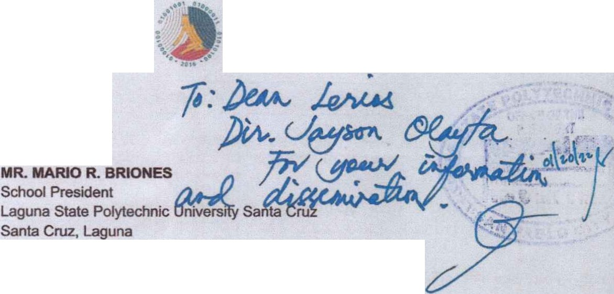

R f l'l R U < llf Tl tf PH I L I PPI

DEPARTMENT OF INFORMATION ANO

COMMUN ICATIONS TECHNOLOGY

17 January 2022

Dear **Mr. Briones:**

The Department of Information and Communications Technology - Luzon Cluster 2 (DICT-LC 2) is hopeful that this communication meets you well and in good health especially during these challenging times.



The ICTIndustry Development Bureau (1108) of the DICT Luzon Cluster 2 will be conducting The Philippine Startup Challenge 2021 (PSC 2021), a national startup competition which aims to encourage andinspire Filipinos to create innovative and relevant ICT products and services that may be viable business ventures and help our country advancein the global digital economy.

As part of the PSC 2021,the DICT Luzon Cluster 2 will organize a Regional Pitching Competition, which will serve as the qualification stage for the national competition amonginterested teams from Region Ill.

In view of the foregoing, we are requesting your support through encouraging your students to participate in the said competition. The Philippine Startup Challenge 2021 has extended its deadline for entries until 31 January 2022.

The following are the important dates to remember for the Student category:

|  |  |  |
| --- | --- | --- |
| Phil ppine Startup ChaUenge 2021 Student Category Calendar | | |
| 31January 2022 | Deadline of submission of entries | |
| 15 February 2022 | Mentoring for Region Ill | |
| 17 February 2022 |  |  |
| Mentoring for RegionIV-A | |
| 23 February 2022 | RegionalPitching for Region Ill | |
| 24 February 2022 | Regional Pitching for Region IV-A | |
| 2 March 2022 | Mentoring for Semifinals | |
| 2nd week of March | National Semifinals | |

Department ofInformation and Communlcattons Technology - Luzon Regional Cluster Office *2*

3/F Monson Square Budding.Cogoyon Volley Rood.Sta. Rita. Gu1gu·nto. Bulacan

Tel No.:+63 (044) 792-37-43; e-moil address:luzoncluster2 dict.gov.ph

I



IH l l L f OF Tlll tlll ll'Pl1'.f S

DEPARTMENT OF INFORMATION AND

COMMUNICATIONS TECHNOLOGY

4th week of March National Finals

As indicated,the 1108 will organize a series of activities to fully equip the participants upon the acceptance of entries. These initiatives serve as our intervention to capacitate and develop startup teams joining the competition. ·

Interested participants from your institution may register through this link:

dJ

x2X104UgNPHPXGQPyg/viewform.

Interested participants may know more about the mechanics of the challenge through this link: https d ;irt 021/.

We believe that your support will help us to engage our students and improve their startup ideas. Exciting prizes and mentoring programs await the winners.

Should you have any inquiries, your designated staff may directly coordinate with DICT llDB Focal Person Ms. Gav Herrera, through email at ' .o .....n or DICT Laguna Provincial Head, Engr. Rex C.Aguila through emailat rex.aguil[a@dict.gov.ph](mailto:a@dict.gov.ph) or via mobile number at 0917- 8994557.

Thank you and we are hoping for your usual support regarding this matter. For your kind attention and action.

With cordial regards,

Dtgitally signed

°':> bySy Reynaldo

Tan

**ENGR. REYNALDO T. SY**

Regional Director DICT Luzon Cluster 2

Department ofInformation and Communications Technology - Luzon Regional Cluster Office 2 3/F Morison Square Butd;ng,Cogoyon Volley Rood Sfo. R1to. Gutguinto, Bulacan

Tel No.:-1-63 (Q U) 792-3743; e mo Iaddress: 1uzonclus1er2 d'ct.gov.ph

I